
Software Engineering Department
Capstone Project Phase B

MsgGuard - Generative AI for Phishing Detection and Prevention

Github: https://github.com/Eleia522000/phishing-ai-detector

Supervisor: Dr. Reuven Cohen Project ID : 26-1-D-28

Submitted by:

Name Eleia Elias Enab Fouad
ID 208173021 212697239
E-mail Eleia.elias@e.braude.ac.il Enab.fouad@e.braude.ac.il

Table of Contents
Contents
Abstract 5
1. Problem and Background 5
1.1 The Problem 5
1.2 Literature and Technology Background 6
1.3 Existing Solutions and Limitations 6
1.4 Project Need 7
1.5 Stakeholders 7
1.6 Project Scope 7
2. General Description of the Implemented System 7
2.1 System Goal 7
2.2 Target Users 8
2.3 Implemented Features 8
2.4 Implemented Requirements 8
2.5 System Components 9
3. Implemented Solution 9
3.1 High-Level Architecture 9
3.2 Backend API 10
3.3 URL Extraction and Preprocessing 10
3.4 BERT-Based AI Component 10
3.5 Identity-Based Verification Components 11
3.5.1 Domain Age Verification 11
3.5.2 IP Geolocation Check 11
3.5.3 Brand-Domain Matching 11
3.6 Decision Logic 12
3.7 User Interface 13
3.8 System Output and Explanation 13
3.9 Activity Diagram 14
4. Engineering Development Process 14
4.1 Development Stages 14
4.2 Tools and Technologies Used 15
4.3 Dataset and Model Training 15
4.4 Backend Implementation 16
4.5 Mobile Application Implementation 16
4.6 Integration 16
4.7 Project Structure 17
5. Challenges, Decisions, and Solutions 17
5.1 Technical Challenges 17
5.2 Design Decisions 17
5.3 Limitations 18
5.4 Lessons Learned 18
6. Verification and Evaluation 19
6.1 Verification Testing 19
6.2 Verification Test Cases 19
6.2.1 Representative Evaluation Inputs 20
6.3 BERT Training and Internal Test Results 21
6.4 Full System Quantitative Results 22
6.5 Conclusions From the Evaluation Results 23
7. Project Conclusions 23
8. References 24
Appendix A - User Guide 25
A.1 Introduction 25
A.2 How to Analyze a Suspicious Message or URL 25
A.3 Understanding the Result 26
A.4 User Help 27
Appendix B - Maintenance Guide 27
B.1 System Environment 27
B.2 Project Directory Structure 28
B.3 Running the Backend 30
B.4 Running the Mobile Application 30
B.5 Updating the System 30
B.6 Recommended Future Maintenance 31

Abstract
Phishing remains one of the most damaging cyber threats because attackers imitate trusted brands, use urgent wording, and create domains that look similar to legitimate services. MsgGuard addresses this problem through a practical Android application. The system analyzes suspicious messages and URLs by combining a fine-tuned BERT model with identity-based verification checks.
The implemented solution uses BERT as the main AI classifier and adds three explainable identity checks: WHOIS-based domain age verification, IP geolocation analysis, and brand-domain matching. These checks are not used as independent final decisions. Instead, they provide supporting evidence that is combined with the model output in the final decision stage. This design helps the system remain understandable for non-technical users while still using machine-learning-based detection.
The final product includes the Android user interface, the backend analysis API, trained model files, identity-checking modules, decision logic, testing scenarios, a user guide, and a maintenance guide. The complete MsgGuard system was functionally evaluated as an end-to-end phishing detection solution. In a preliminary evaluation on a balanced external dataset of 1,000 samples, the system achieved approximately 99.7% accuracy. However, because the evaluation dataset was controlled and balanced, this result may not fully represent real-world performance. Further testing on larger, deduplicated, imbalanced, and fully independent datasets is required.1. Problem and Background

The Problem
Phishing attacks attempt to manipulate users into trusting malicious messages, fake websites, or misleading links. Attackers commonly imitate banks, delivery companies, online stores, social-media platforms, and technology services. They often use urgent language, account-lock warnings, fake payment requests, prize notifications, and requests for personal or authentication information.
Identifying phishing content is especially difficult on mobile devices. URLs may be partially hidden, shortened, or displayed on small screens, making it harder for users to inspect the real registered domain. Suspicious messages may also arrive through SMS, WhatsApp, email, or social-media applications, where traditional organizational email filters may not provide protection.
Existing blacklist-based systems are useful for detecting previously reported malicious domains, but they are less effective against newly registered domains and zero-day phishing campaigns. A malicious domain may be created, used for a short attack, and removed before it is added to a public blacklist.

Machine-learning models can identify suspicious textual and URL patterns, but a model that performs well on a controlled dataset may still fail when attackers use new wording, unfamiliar domains, or previously unseen impersonation techniques. Therefore, a practical phishing-detection system should analyze both the submitted content and the identity of the linked website, while also providing understandable reasons for its decision.

1.2 Literature and Technology Background
Phishing-detection research includes rule-based methods, classical machine-learning models, deep-learning models, and hybrid detection systems. Rule-based approaches analyze visible indicators such as URL length, suspicious keywords, special characters, domain structure, and known malicious patterns. Although these approaches are easy to explain, they may fail when attackers modify their wording or URL structure. Classical machine-learning methods, including Logistic Regression, Support Vector Machines, and Random Forest, use manually engineered features extracted from messages and URLs. Such models can achieve strong results when the selected features represent the tested attacks, but their performance may decrease when new phishing techniques differ from the training data [1], [4], [10]. Deep-learning models reduce the need for manual feature engineering by learning patterns directly from text or URL sequences. Previous studies have demonstrated the use of recurrent networks, stacked models, and other deep-learning architectures for phishing-email and phishing-URL detection [3], [5], [7], [8], [9]. Transformer-based models such as BERT are suitable for phishing-message classification because they analyze words in their surrounding context. This enables the model to detect combinations of urgency, threats, credential requests, payment warnings, and social-engineering intent rather than relying only on individual keywords. Explainability is also important in phishing detection. A system that returns only a safe or unsafe label may not help a non-technical user understand the risk. Recent approaches have therefore explored explainable AI methods that provide reasons or supporting indicators together with the final prediction [6]. Identity-based verification can complement textual classification by examining information that is not visible from the message alone. Domain-registration age, hosting information, registered-domain structure, and brand-domain consistency may reveal impersonation attempts or recently created infrastructure. These indicators should be treated as supporting evidence rather than absolute proof, because legitimate services may also use new domains, cloud providers, or servers in several geographic regions.

1.3 Existing Solutions and Limitations
Existing phishing protection solutions include email filters, browser warnings, security gateways, and browser extensions. These solutions are important, but they do not always match the way users interact with suspicious content on mobile devices. A user may receive a suspicious SMS, WhatsApp message, or social-media link and need a quick explanation before deciding whether to open it.
Another limitation is explainability. Some systems only return a safe or unsafe label without explaining why the content is risky. For non-expert users, a short explanation is useful because it helps them understand the reason behind the warning. MsgGuard focuses on returning a classification together with readable reasons such as suspicious wording, a recently registered domain, brand mismatch, or hosting-origin inconsistency.

1.4 Project Need
The need for MsgGuard comes from the gap between high model accuracy on datasets and real-world phishing behavior. A mobile user needs a simple tool that can quickly analyze suspicious content and return an understandable result. The system therefore focuses on practical detection, clear explanations, and a workflow that fits normal mobile use.
The project implementation also supports an engineering need. The analysis process is divided into separate components: AI classification, domain age verification, IP geolocation checking, brand-domain matching, and final decision logic. This structure helps the system give users a clearer result because the final decision is based on both the AI classification and several explainable identity indicators.

1.5 Stakeholders
- Mobile users who receive suspicious SMS, WhatsApp, email, or social-media messages.
- Organizations and brands affected by impersonation and fake login pages.
- Cybersecurity teams that need additional explainable phishing indicators.
- Future developers who may extend the system with more detection modules or deployment options.

1.6 Project Scope
The scope of Phase B was to implement a working prototype, not a complete commercial security product. The system demonstrates an end-to-end flow from user input in the mobile app to backend analysis and user-facing result. It does not replace enterprise anti-phishing systems, browser warnings, or email gateway protection. Instead, it provides a practical mobile-focused prototype that combines AI detection with explainable identity checks.

2. General Description of the Implemented System

2.1 System Goal
MsgGuard was implemented as a phishing-detection system for mobile users. The user submits a suspicious message or URL through the mobile app. The app sends the input to the Flask backend, where the content is analyzed using the BERT model and identity-based checks. The backend returns a label, a risk score, and explanatory reasons that are displayed to the user.
The system goal is not only to classify the input, but also to help the user understand the result. A warning without context may be ignored, while a warning with concrete reasons can support safer behavior. For that reason, the output includes both the technical classification and short user-readable explanations.

2.2 Target Users
The system is intended for non-expert mobile users. The user is not expected to understand domain registration, IP geolocation, WHOIS records, or machine-learning models. The interface therefore presents the result in simple language and gives clear reasons such as a recently registered domain, brand mismatch, or suspicious message wording.

2.3 Implemented Features
- Mobile application built with React Native and Expo.
- Flask backend API that receives analysis requests and returns JSON results.
- Fine-tuned BERT model for phishing classification.
- RDAP/WHOIS-based domain age verification.
- IP geolocation-based hosting-origin check.
- Brand-domain matching for detecting impersonation and misleading domain structures.
- Final decision logic that combines AI output with identity indicators.
- User-facing explanation of the main reasons behind the result.
- Error handling for empty or invalid input.

2.4 Implemented Requirements
The implementation satisfies the main project requirements in a practical prototype form. The system accepts suspicious content, extracts URLs when they exist, analyzes the text with BERT, executes identity checks for domain-related evidence, combines the signals, and presents a clear result to the user.
Functional Requirements
- The user can submit a suspicious message or URL.
- The backend validates the submitted input.
- The system extracts URLs and domain information from the message.
- The BERT model classifies the content as phishing or legitimate.
- The system checks domain age using WHOIS information.
- The system checks hosting-origin information using IP geolocation.
- The system checks brand-domain consistency to detect impersonation.
- The system combines the results into a final classification and explanation.
Non-Functional Requirements
- Usability: the application presents the result in simple language for non-expert users.
- Explainability: the system gives short reasons behind the classification, not only a label.
- Response time: the system is designed to return the analysis quickly enough for normal mobile use.
- Reliability: the system handles normal messages, URLs, messages with embedded links, and invalid input without crashing.

2.5 System Components
The implemented system is composed of several cooperating components. The mobile application is responsible for user interaction. The backend API receives the submitted input and coordinates the analysis. The BERT model provides the main AI prediction. The identity-verification modules provide domain-level evidence. The decision logic combines all available signals into a final result.
This structure follows a clear separation of responsibilities. The frontend does not run the heavy model or perform domain analysis. Instead, it sends the suspicious content to the backend and displays the returned result. The backend contains the logic that may change over time, such as model loading, threshold decisions, domain checks, and explanation generation.

3. Implemented Solution

3.1 High-Level Architecture
The architecture contains five main stages: mobile input, backend API, AI analysis, decision logic and scoring, and user result. The mobile app sends the submitted content to the backend, where the analysis is performed. The backend then returns a final label, risk score, and explanation that are displayed clearly to the user.
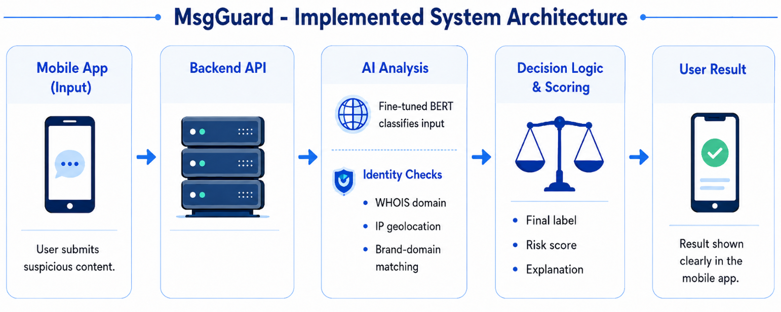
Figure 1: Implemented MsgGuard system architecture.

3.2 Backend API
The backend is implemented in Python using Flask. The main analysis endpoint receives the submitted message or URL, validates the input, extracts URLs, sends the text to the BERT model, runs identity checks when a URL is present, and returns a structured JSON response. The backend acts as the coordination layer between the mobile app, the trained model, and the supporting verification modules.
The API is designed to keep the frontend simple. The mobile app does not need to know how domain age is checked or how the model performs inference. It only sends the input and receives the final response. This design also makes it easier to improve the backend later without changing the mobile interface, as long as the returned JSON fields remain stable.
The backend response includes the final classification, risk score, risk level, and explanation. This format supports the user interface because the app can directly display the result without performing additional security analysis on the device.
The backend exposes a /health endpoint for checking system availability and an /analyze endpoint for processing submitted messages and URLs.

3.3 URL Extraction and Preprocessing
Before running domain-related checks, the backend extracts URLs from the submitted text. If the input contains a full URL, the system identifies the domain and prepares it for RDAP/WHOIS, geolocation, and brand-domain analysis. If the message does not contain a URL, the system still performs BERT-based text classification and returns a result based on the message content.
Preprocessing is important because phishing messages often contain extra text around a link. The backend must separate the message text from the URL-related evidence. This allows the AI component to analyze the full message while the identity modules analyze the domain itself. The separation also helps avoid trusting misleading subdomains that only visually contain a brand name.
The system then uses urlparse and tldextract to separate the hostname, subdomain, registered domain, and suffix.

3.4 BERT-Based AI Component
The AI component uses a fine-tuned BERT model to classify phishing and legitimate content. BERT was selected because phishing messages often depend on context, wording, and intent. The model can analyze full message meaning instead of relying only on simple keywords. In the implemented system, BERT provides the main machine-learning prediction, which is then used by the backend as one input to the final decision.
The model is useful for detecting wording patterns such as urgency, account verification requests, prize claims, payment warnings, and requests for sensitive information. These patterns may appear in different forms, so a contextual model is more suitable than a simple keyword list. However, the model result is not treated as the only source of truth. It is combined with identity checks to produce a more explainable final decision.
Before inference, the input is tokenized, padded, and truncated to 128 tokens. The model output is converted into a phishing probability using Softmax. This probability contributes up to 50 points to the final risk score, so BERT remains an important signal but does not make the final decision alone.
The additional components are not intended only to improve accuracy. They verify information that BERT cannot confirm, such as the real registered domain, domain age, hosting location, and official brand identity. They also provide explanations for the final result.

3.5 Identity-Based Verification Components

3.5.1 Domain Age Verification
The domain age module checks how long a domain has existed using RDAP, with WHOIS used as a fallback when the required creation date is unavailable. The system calculates the domain age by comparing the registration date with the current date. Recently registered domains add supporting risk because phishing campaigns often use newly created domains. However, domain age is not treated as an independent phishing decision, since legitimate domains may also be new. If no creation date is available, the module reports the information as unavailable and adds no domain-age risk.
The scoring thresholds are based on the calculated domain age. A domain younger than 30 days adds 25 risk points, a domain younger than 180 days adds 15 points, and a domain younger than one year adds 8 points. If the creation date is unavailable, no risk points are added.

3.5.2 IP Geolocation Check
The IP geolocation module resolves the registered domain to an IP address using DNS and sends the IP address to the ipwho.is service, which returns the hosting organization and server location. When a recognized brand is detected, the returned country code is compared with a predefined and maintainable list of expected brand regions. A mismatch may add supporting risk to the final score, but it does not independently classify the input as phishing. This comparison is skipped for trusted official domains because legitimate companies may use cloud providers, CDNs, and servers in multiple countries. Therefore, geolocation is treated only as contextual evidence.It adds 15 risk points when a relevant mismatch is detected

3.5.3 Brand-Domain Matching
The brand-domain matching module checks whether a domain is consistent with a claimed brand. The system uses tldextract to separate the registered domain, subdomain, and suffix, and compares them with a predefined list of official brand domains. Exact matches are treated as trusted, while non-exact matches are analyzed using character-substitution normalization, Python’s SequenceMatcher, and a Levenshtein edit-distance algorithm to detect misspellings and homoglyph attacks. The module also checks for brand names placed in misleading subdomains, unrelated main domains, or unofficial top-level domains. This helps detect cases where attackers use visually similar or misleading domains to imitate trusted brands.
Character normalization converts common substitutions such as 0 to o, 1 to l, and @ to a. Brand inference uses a similarity threshold of approximately 0.82 or an edit distance of two characters or fewer. During the consistency check, a similarity of at least 0.80 or an edit distance of two characters or fewer is treated as suspicious evidence.

3.6 Decision Logic
The final decision logic combines BERT output with rule-based message, URL, and identity indicators. Each component calculates a separate score for BERT confidence, suspicious wording, URL structure, domain age, IP geolocation, and brand-domain matching. For URL-only input, BERT and message-wording analysis are skipped. Otherwise, the strongest score among the BERT, wording, and URL analyses is used as the initial risk score. Escalation rules may increase the score when several strong indicators appear together, while trusted official domains may reduce it when no strong phishing evidence is detected.
The decision flow is implemented as follows:
1.Receive a message or URL from the mobile application.
2.Extract URLs and determine whether the input contains message text or only a URL.
3.Run BERT and suspicious-wording analysis when message text is available.
4.Run URL-structure, RDAP/WHOIS domain-age, IP-geolocation, and brand-domain checks when a URL exists.
5.Calculate separate scores and apply escalation or trusted-domain rules.
6.Limit the final score to 0–100 and classify it as Legitimate, Suspicious, or Phishing.
7.Return the final label, risk score, and explanation findings to the mobile application.
The final classification thresholds are:
- 0–34: Legitimate, Low Risk
- 35–59: Suspicious, Medium Risk
- 60–100: Phishing, High Risk

This logic improves explainability because each result can be traced to specific findings, such as suspicious wording, a recently created domain, a brand-domain mismatch, or a hosting-region mismatch.

3.7 User Interface
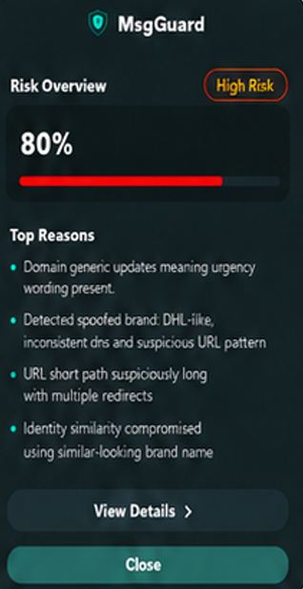
The mobile user interface was implemented with React Native and Expo. It allows the user to submit suspicious content and view the final analysis result. The main screens of the application are shown below.
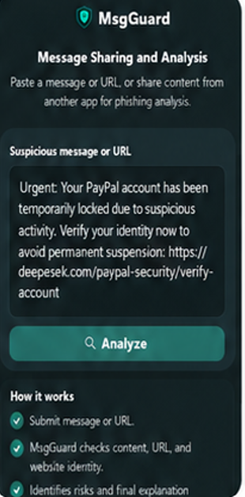

3.8 System Output and Explanation
The system output is designed to be understandable for non-technical users. The final screen presents a classification of Legitimate, Suspicious, or Phishing, together with a risk score, risk level, and a short explanation.
Each analysis module returns a numerical score and textual findings. These findings may describe BERT confidence, suspicious wording, URL-structure indicators, domain age, hosting information, or a brand-domain mismatch. The backend combines the findings from all executed modules and removes duplicate explanations while preserving their original order.
The backend collects the findings produced by the different analysis modules and removes repeated findings. The main result screen displays up to five of the most relevant reasons. These explanations are based on predefined rules in the system, so each explanation is directly connected to a detected risk indicator.
This explanation helps the user understand why caution is recommended. For example, the system may report urgent wording, a recently registered domain, a misleading URL structure, an unexpected hosting region, or a mismatch between the claimed brand and the registered domain.

3.9 Activity Diagram
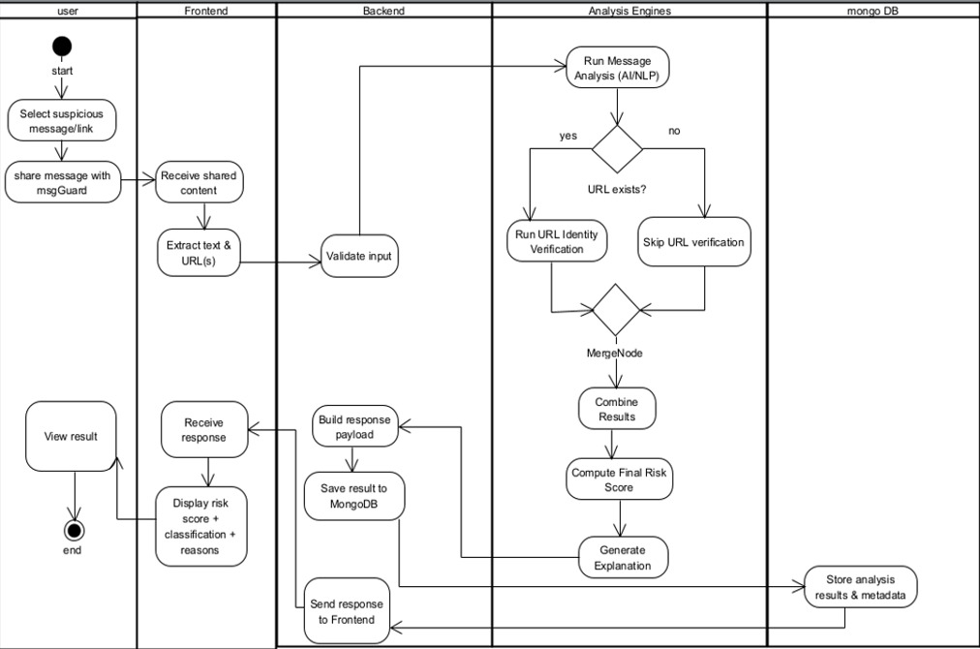

4. Engineering Development Process

4.1 Development Stages
The development process was carried out in several iterative stages. First, the datasets were prepared and converted into binary Legitimate and Phishing classes. The BERT model was then fine-tuned, validated, and tested separately before being integrated into the complete system. The development process was divided into the following stages: dataset preparation, BERT training, backend development, identity-check implementation, mobile application development, system integration, and evaluation. Each stage was tested separately before being connected to the next component.
In parallel, the Flask backend and React Native mobile application were developed. The backend was designed to validate user input, extract URLs, run the BERT model, execute domain-age, IP-geolocation, URL-structure, and brand-domain checks, and return a structured result to the application.
The identity-checking modules were integrated gradually so that each component could be tested independently before affecting the final risk score. During integration, issues such as unavailable domain-registration dates, false warnings for legitimate domains, duplicate explanations, and inconsistent response fields were identified and corrected. Finally, automated evaluation and manual end-to-end tests were performed to verify the complete flow from user input to the displayed result.
Development progress was reviewed with the project supervisor during the project. Feedback was used to improve the system architecture, algorithm descriptions, evaluation process, user documentation, and maintenance instructions.

4.2 Tools and Technologies Used
- Python for backend development, preprocessing, and model integration.
- Flask for the API endpoint and request handling.
- BERT and transformer libraries for text-based phishing classification.
- RDAP services and the python-whois library for domain-registration and age verification.
- tldextract, SequenceMatcher, and Levenshtein distance for domain decomposition and brand-domain comparison.
- IP geolocation service for hosting-origin analysis.
- React Native and Expo for mobile application development.
- MongoDB for storing project-related data and supporting future data management.
- VS Code and standard Python tools for implementation and testing.

4.3 Dataset and Model Training
The project used labeled phishing and legitimate data obtained from both Hugging Face[11] and Kaggle[12], with each source serving a different purpose in the development and evaluation process.
The final BERT model was trained using the PhishingEmailDetectionv2.0 dataset[11] published on Hugging Face. This dataset contains 200,000 labeled samples in total, divided into 120,000 training samples, 20,000 validation samples, and 60,000 test samples. It includes 22,644 email samples and 177,356 URL samples. The original dataset contains four classes: legitimate emails, phishing emails, legitimate URLs, and phishing URLs. For MsgGuard, these four classes were converted into two binary classes: Legitimate and Phishing.
The BERT model learned both textual and URL-related phishing patterns from this dataset. Email samples helped the model recognize suspicious wording, urgency, credential requests, and social-engineering techniques, while URL samples helped it learn lexical and structural patterns associated with legitimate and malicious links.
A separate phishing email dataset was obtained from Kaggle [12]. This dataset was kept separate from the final BERT training data and was used for external evaluation of the complete MsgGuard system. From this dataset, a balanced evaluation subset of 1,000 samples was selected, consisting of 500 legitimate samples and 500 phishing samples.

4.4 Backend Implementation
The backend was implemented as a Flask application. It receives requests from the mobile app, validates the input, calls the BERT model, executes identity modules, and formats the final response. The backend returns structured information, including the final classification, risk score, and explanation fields.
The backend modules were first tested independently. URL extraction, BERT inference, domain-age lookup, geolocation, brand matching, scoring, and explanation generation were then connected gradually through the main analysis flow.
The backend is the central part of the implemented solution because it coordinates all analysis components. It must handle normal messages, URLs, messages with embedded links, and invalid input. It must also keep the response format stable so that the frontend can display results without needing to know the internal details of the model or identity checks.

4.5 Mobile Application Implementation
The mobile application was implemented using React Native and Expo. The app provides the user-facing interface and communicates with the backend API. The mobile side focuses on simplicity: the user submits suspicious content, the app sends the request, and the result is displayed in a clear format.
The mobile interface was designed for non-technical users. It avoids exposing raw technical values unless they are useful for understanding the result. The main goal of the interface is to support quick decision-making: the user should be able to understand whether the content appears legitimate, suspicious, or phishing.
Support for receiving shared content from other mobile applications was added after the basic manual-input flow was completed.

4.6 Integration
Integration focused on connecting the mobile application with the Flask backend and ensuring that backend responses are displayed correctly. The backend needed to return consistent JSON fields so the frontend could present the classification and explanation without requiring additional processing on the device.
Integration testing also helped verify that the user-facing flow worked as expected. The system needed to accept input, call the backend, wait for analysis, receive the response, and display the correct result. This step is important because individual modules can work correctly while the complete system still fails because of mismatched fields, incorrect endpoint configuration, or network issues.
Integration was verified using both automated requests to the /analyze endpoint and manual tests through the mobile application. This confirmed that the same backend result was received and displayed correctly by the frontend.

4.7 Project Structure
The repository structure separates the backend, mobile application, model-related files, and documentation. This organization is important because the project combines mobile development, backend development, machine-learning integration, and identity-verification logic.
The backend area contains the Flask application, analysis endpoint, model-loading logic, and identity-checking modules. The mobile application area contains the React Native interface and API communication code. Model files, training code, evaluation outputs, and project documentation are stored in separate directories to support reproducibility and future maintenance.

5. Challenges, Decisions, and Solutions

5.1 Technical Challenges
Several technical challenges appeared during development. The first challenge was combining BERT predictions with rule-based checks without allowing one weak indicator to control the final result. Initially, adding all scores directly could produce exaggerated risk values. The solution was to calculate separate scores for BERT, message wording, URL structure, domain age, geolocation, and brand matching, and then use the strongest signal together with escalation rules when several suspicious indicators appear.
A second challenge was retrieving reliable domain-registration data. WHOIS did not always return a creation date for every domain. To improve reliability, RDAP was added as the primary lookup method and WHOIS was kept as a fallback. When neither method returns a valid date, the system reports the information as unavailable and does not add domain-age risk.
Another challenge was reducing false positives. Legitimate domains may be new, use subdomains, or be hosted through cloud providers and CDNs in different countries. Therefore, domain age and geolocation are treated only as supporting evidence, while trusted official domains are handled separately. BERT is also skipped for URL-only input because suspicious words inside a URL could incorrectly influence the text classifier.
Brand impersonation was difficult because attackers use misspellings, character substitutions, and misleading subdomains. This was addressed using trusted-domain lists, domain decomposition, character normalization, string similarity, and edit distance. Finally, the backend response fields and explanations were standardized and duplicate findings were removed so the mobile application could display consistent results.

5.2 Design Decisions
The main design decision was to combine AI classification with identity-based verification checks instead of relying on one method only. The AI model analyzes the submitted message or URL text, while the identity checks provide additional domain-level evidence such as domain age, IP geolocation, and brand-domain consistency.
Another important design decision was to treat each identity check as supporting evidence rather than as a final decision by itself. This was especially important for domain age, because a recently registered domain can be suspicious, but a new domain can also be legitimate.
The final decision is based on the combination of several signals. This design helps the system produce a more balanced result and allows the user to receive a clearer explanation, such as suspicious wording, new domain, brand mismatch, or unusual hosting-origin information.

5.3 Limitations
The complete MsgGuard system was tested at model, backend, and end-to-end levels. The main evaluation limitation is therefore not missing component testing, but the representativeness of the test data. The external evaluation used a controlled and balanced set of 1,000 samples, while real-world phishing data is usually imbalanced and changes over time. Future evaluation should use larger, deduplicated, time-separated, and realistically imbalanced datasets.
Another limitation is that some phishing attempts may use wording, domains, or impersonation methods that were not represented in the training data. The identity-based checks reduce this limitation, but they do not remove it completely.
Brand-domain matching also depends on the quality and coverage of the brand-reference list. If a brand is missing from the list, the system may not detect that specific impersonation attempt. IP geolocation also has limitations because legitimate companies may use cloud providers, content delivery networks, and multiple hosting regions. For this reason, geolocation is treated only as supporting evidence rather than as an independent final decision.

5.4 Lessons Learned
- Combining AI classification with identity-based checks improves explainability because users receive reasons, not only a label.
- Identity checks should be treated as supporting evidence rather than absolute proof.
- Domain age is useful, but it must be handled carefully because not every new domain is malicious.
- AI model results should be supported by additional indicators because phishing attacks can change over time.
- End-to-end evaluation of the complete system is important because model-level performance alone does not fully represent the final user-facing result.
- A stable backend response format is important because the mobile application depends on consistent fields such as classification, risk score, risk level, and explanation.
- the external full-system evaluation should have been planned earlier in the development process rather than mainly after integration.
-Model-only results and complete-system results should have been separated clearly from the beginning to avoid confusion between BERT performance and the performance of the hybrid system.
-A larger automated collection of brand-impersonation, URL-only, and geolocation edge cases would have allowed the scoring thresholds to be validated earlier.

6. Verification and Evaluation

6.1 Verification Testing
Verification focused on checking whether the implemented system behaves correctly in representative user scenarios. Each scenario checks both the classification result and the explanation returned to the user. This is important because the system is not only expected to classify input, but also to explain the result in a way the user can understand.
The verification process included scenarios for legitimate URLs, phishing URLs, brand impersonation, misleading subdomains, messages without URLs, and invalid input. These scenarios check that the system does not crash, that it returns a structured result, and that the explanation is connected to the detected risk indicators.
The project was tested at three different levels. First, the BERT model was evaluated during the model-development process using validation data and a held-out internal test set of 60,000 samples. Second, the complete MsgGuard pipeline was quantitatively evaluated on 1,000 external samples processed through the backend. Third, manual end-to-end tests were performed using representative scenarios to verify the mobile application, API communication, identity checks, risk scoring, explanations, and error handling.
Before the end-to-end evaluation, the main backend components were also tested separately, including URL extraction, domain-age lookup, IP geolocation, brand-domain matching, decision logic, explanation generation, and invalid-input handling.

6.2 Verification Test Cases
- Legitimate URL: the system recognized official domains and avoided unnecessary warnings.
- Phishing URL: the system classified suspicious input as phishing or suspicious.
- Recently registered domain: the system identified domain age as a risk indicator when relevant.
- Brand impersonation: the system detected mismatch between the claimed brand and the real domain.
- Misleading subdomain: the system extracted the true registered domain and did not rely only on the subdomain text.
- Unexpected hosting origin: the system reflected hosting-origin risk when this indicator was relevant.
- Message without URL: the system still performed AI-based message analysis.
- Invalid input: the system returned a clear error response instead of crashing.

6.2.1 Representative Evaluation Inputs
Input Type | Example | Suspicious Indicators | Detection Component
Suspicious message | “Your account will be suspended today. Verify your password immediately.” | Urgency, threat, and request for sensitive information | BERT and message-wording analysis
Character-substitution URL | https://amaz0n-account.example/login | 0 replaces o, suspicious words, and non-official domain | Brand-domain and URL analysis
Misleading subdomain | https://microsoft.security-check.example/verify | Brand name appears in the subdomain, but the real registered domain is unrelated | Domain extraction and brand matching
Suspicious URL structure | https://secure-account-update.example/login | Hyphens and terms such as secure, account, update, and login | URL-structure analysis
Recently registered domain | A domain created 12 days before the analysis | Domain age is below 30 days | RDAP/WHOIS domain-age check
Unexpected hosting region | A non-official domain claiming to represent a known brand, while its server country differs from the predefined expected region | Location mismatch used as supporting evidence | DNS and IP geolocation
Legitimate comparison | https://www.microsoft.com | Domain matches the trusted-domain list | Trusted-domain verification

6.3 BERT Training and Internal Test Results
The BERT model was evaluated as part of the model-training process using the internal test split. These results represent the performance of the trained BERT classifier only. They do not include the additional components of the complete MsgGuard system, such as URL extraction, WHOIS and hosting analysis, brand-domain matching, decision logic, and user-facing result generation.
The trained BERT model achieved a final accuracy of 0.99553, equivalent to approximately 99.55%, on a total of 60,000 samples.
The internal test set included:
- 30,130 legitimate samples
- 29,870 phishing samples
The confusion matrix results were:
- 30,007 legitimate samples were correctly classified as legitimate.
- 123 legitimate samples were incorrectly classified as phishing.
- 29,725 phishing samples were correctly classified as phishing.
- 145 phishing samples were incorrectly classified as legitimate.
Figure 4: BERT Model Confusion Matrix
Out of the 60,000 samples in the internal test split, 59,732 were classified correctly, while 268 samples were misclassified.
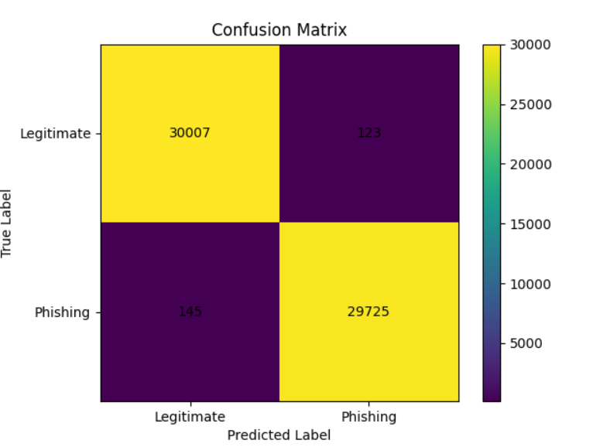
Figure 4: BERT model confusion matrix.

6.4 Full System Quantitative Results
The complete MsgGuard backend pipeline was evaluated on a balanced external subset of 1,000 email and message samples obtained from the Kaggle dataset [12]. The subset included 500 legitimate samples and 500 phishing samples. Each sample was processed through the /analyze endpoint. URL-specific and edge-case scenarios were evaluated separately through manual end-to-end testing.
.
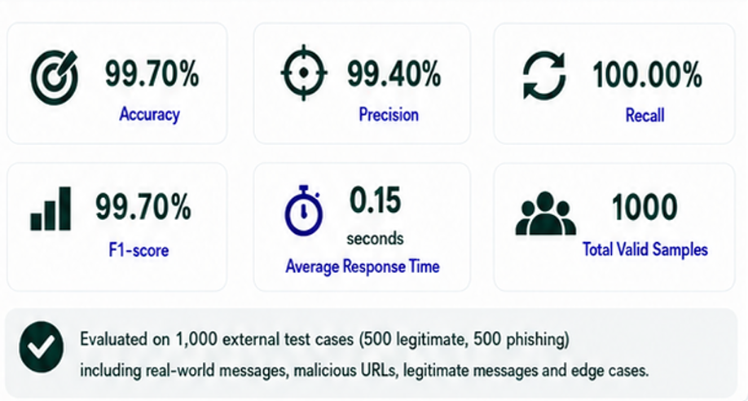

Figure 5: Full system quantitative evaluation results.

6.5 Conclusions From the Evaluation Results
The evaluation results show strong performance for both the BERT model and the complete MsgGuard system under the tested conditions. The BERT model achieved approximately 99.55 percent accuracy on 60,000 internal test samples, with 268 total misclassifications.
The complete system was evaluated on a balanced external set of 1,000 cases, including legitimate messages, phishing messages, malicious URLs, and edge cases. It achieved 99.70 percent accuracy, 99.40 percent precision, 100.00 percent recall, and a 99.70 percent F1-score, with an average response time of 0.15 seconds.
The two evaluations measure different levels of the project. The BERT evaluation measures only the trained classifier, while the full-system evaluation includes URL analysis, identity checks, decision logic, and user-facing result generation. Because the external dataset was balanced and controlled, these results should be considered preliminary and may not fully represent real-world performance.
The hybrid design adds explainable domain-level evidence to the BERT prediction. The identity checks help the system explain why a message or URL was classified as legitimate, suspicious, or phishing. However, a direct comparison between BERT-only and the complete hybrid system on the same external dataset is still required to measure the exact contribution of the additional components.

7. Project Conclusions
The Phase B implementation achieved the main goal of building a working phishing-detection system. MsgGuard includes a mobile application, a Flask backend, a fine-tuned BERT model, and identity-based verification checks. The system provides both a classification and a short explanation, which makes it more useful for ordinary users than a black-box label alone.
The project demonstrates the value of combining AI-based analysis with identity-based verification. BERT is useful for detecting suspicious message and URL patterns, while RDAP/WHOIS domain-age verification, IP geolocation, and brand-domain matching provide explainable domain-level evidence. This combination supports practical phishing detection because it allows the system to return both a final result and understandable reasons. The additional components are valuable not only for classification, but also because they verify information that BERT cannot independently confirm and provide traceable explanations for the user.
The evaluation results also support the implemented design. The BERT model achieved strong performance on the model evaluation dataset, and the full system evaluation showed strong results on external test cases. These results indicate that MsgGuard can provide accurate and understandable phishing detection in a mobile-focused workflow.
Future work should focus on expanding the brand-reference database, improving deployment stability, testing the system with more real-world mobile users, improving safe logging and monitoring, and adding more continuous feedback mechanisms. These improvements would move MsgGuard from an academic prototype toward a more robust real-world tool.

8. References
[1] Nguyet Q., Ali S., Ondryj K. Deep Learning for Phishing Detection: Taxonomy, Current Challenges, and Future Directions. IEEE Access, 2022. https://doi.org/10.1109/ACCESS.2022.3151903
[2] Maruf A., Khin L., Alamgir H. Intelligent phishing detection scheme using deep learning algorithms. Journal of Enterprise Information Management, 2020. https://www.emerald.com/jeim/article/36/3/747/203279/Intelligent-phishing-detection-scheme-using-deep
[3] Samer Atawneh, Hamzah Aljehani. Phishing Email Detection Model Using Deep Learning. Electronics, 12(20), 4261, 2023. https://www.mdpi.com/2079-9292/12/20/4261
[4] Cagatay Catal, Gorkem Gul, Bider T. Applications of Deep Learning for Phishing Detection: a Systematic Literature Review. Knowledge and Information Systems, 2022. https://pmc.ncbi.nlm.nih.gov/articles/PMC9125357/
[5] Sultan Asiri, Yang Xiao, Saleh Alzahrani, Tieshan Li. PhishingRTDS: A Real-time Detection System for Phishing Attacks Using a Deep Learning Model. Computers and Security, 2024. https://www.sciencedirect.com/science/article/abs/pii/S0167404824001445
[6] Bryan Lim, Roman Huerta, Alejandro Sotelo, Anthonie Quintela, Priyanka Kumar. EXPLICATE: Enhancing Phishing Detection through Explainable AI and LLM-Powered Interpretability. arXiv, 2025. https://arxiv.org/abs/2503.20796
[7] Saba Aslam, Hafsa Aslam, Arslan Manzoor, Chen Hui, Abdur Rasool. AntiPhishStack: LSTM-based Stacked Generalization Model for Optimized Phishing URL Detection. arXiv, 2024. https://arxiv.org/abs/2401.08947
[8] Qazi Haq, Iftikhar A. Detecting Phishing URLs Based on a Deep Learning Approach. Applied Sciences, 2024. https://www.mdpi.com/2076-3417/14/22/10086
[9] Anish Rawla, Preeti et al. Detection of Phishing Attacks in PhiUSIIL Dataset Using Deep Learning. Procedia Computer Science, 2025. https://www.sciencedirect.com/science/article/pii/S1877050925011007
[10] Dinnillah A.H., Widiarto M., Wijaya A. Robust Phishing Detection Using Random Forest with Isolation Forest Based Outlier Filtering. IJACI, 2025. https://journal.cendekiajournal.com/ijaci/article/view/16
[11] CyberSecTony, “PhishingEmailDetectionv2.0,” Hugging Face Datasets.
https://huggingface.co/datasets/cybersectony/PhishingEmailDetectionv2.0
[12] Subhajournal, “Phishing Email Detection,” Kaggle.
https://www.kaggle.com/datasets/subhajournal/phishingemails

Appendix A - User Guide

A.1 Introduction
This guide is intended for regular users of the MsgGuard mobile application. It explains the normal successful use flow of the system and how to understand the result. The user does not need cybersecurity knowledge in order to use the application.

A.2 How to Analyze a Suspicious Message or URL
The main screen contains a text input area for entering a suspicious message or URL and an Analyze button for starting the analysis. The user may paste complete message content or share the message from another app , a single URL, or a message containing an embedded link.
1. Open the MsgGuard application or share suspicious content to MsgGuard from another mobile application.
2. Paste or submit the suspicious message or URL.
3. Press the analyze button.
4. Wait until the analysis is completed.
5. Read the final classification shown by the application.
6. Review the risk score and short explanation.
7. Avoid opening the link if the system marks it as suspicious or phishing.


The main screen allows the user to enter a suspicious message or URL in the text area.

A.3 Understanding the Result
- Legitimate means the input did not show strong phishing indicators.
- Suspicious means the system found one or more risk indicators and the user should be careful.
- Phishing means the input appears malicious or strongly risky.
- The explanation lists the main reasons, such as suspicious wording, new domain, brand mismatch, or hosting-origin inconsistency.
The explanation is meant to help the user understand the warning rather than only seeing a technical score. If the result is suspicious or phishing, the safest action is to avoid opening the link and avoid entering personal details.

The result screen displays the calculated risk score, risk level, and the main reasons that influenced the classification. The user can press View Details for additional information or Close to return to the main screen.

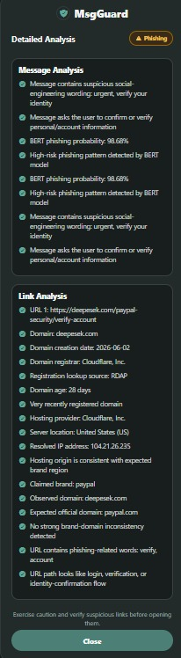

The screen shows detailed message and link findings after the user presses on view details button, including BERT results, domain information, hosting location, and brand verification.

A.4 User Help
The application guides the user by showing clear result messages and short explanations. The recommended behavior is to avoid interacting with content marked as suspicious or phishing.

Appendix B - Maintenance Guide

B.1 System Environment
- Backend language: Python.
- Backend framework: Flask.
- Frontend framework: React Native with Expo.
- AI component: fine-tuned BERT model.
- Identity checks: WHOIS lookup, IP geolocation, and brand-domain matching.
- Database: MongoDB for project-related data storage and future data management.
- Repository: https://github.com/Eleia522000/phishing-ai-detector
The backend requires Python 3 and pip. The mobile application requires Node.js, npm,
Expo, and either Expo Go or an Android emulator. Internet access is required for RDAP,
WHOIS, DNS resolution, and IP-geolocation checks. MongoDB is optional and is used only
when database storage is configured.

B.2 Project Directory Structure

phishing-ai-detector/

│

├── Backend/ — Contains the Flask backend and phishing-analysis modules.

│ ├── __init__.py — Defines the Backend directory as a Python package.

│ ├── msgguard.py — Starts the Flask server and defines the API endpoints.

│ ├── config.py — Stores project paths, environment settings, brand data, and analysis constants.

│ ├── database.py — Connects to MongoDB and stores analysis results.

│ ├── requirements.txt — Lists the Python packages required by the backend.

│ │

│ ├── analyzers/ — Contains the phishing-analysis modules.

│ │ ├── __init__.py — Defines the analyzers directory as a Python package.

│ │ ├── message_analyzer.py — Detects suspicious wording and social-engineering patterns.

│ │ ├── url_analyzer.py — Extracts URLs and analyzes their structure.

│ │ ├── brand_analyzer.py — Checks brand-domain consistency and impersonation patterns.

│ │ └── domain_analyzer.py — Performs RDAP, WHOIS, DNS, domain-age, and IP-geolocation checks.

│ │

│ ├── services/ — Contains machine-learning services.

│ │ ├── __init__.py — Defines the services directory as a Python package.

│ │ └── bert_service.py — Loads the trained BERT model and calculates phishing probability.

│ │

│ ├── decision/ — Contains the final decision logic.

│ │ ├── __init__.py — Defines the decision directory as a Python package.

│ │ └── decision_engine.py — Combines the analysis scores and generates the final result.

│ │

│ └── utils/ — Contains shared helper functions.

│ ├── __init__.py — Defines the utils directory as a Python package.

│ └── helpers.py — Provides duplicate removal, similarity, edit-distance, and normalization functions.

│

├── Frontend/ — Contains the React Native and Expo mobile application.

│ ├── app/ — Contains the application screens, routes, and main interface logic.

│ ├── assets/images/ — Stores images and visual resources.

│ ├── components/ — Contains reusable user-interface components.

│ ├── constants/ — Contains shared frontend constants.

│ ├── hooks/ — Contains reusable React hooks.

│ ├── scripts/ — Contains frontend utility scripts.

│ ├── app.json — Contains the Expo application configuration.

│ ├── eas.json — Contains Expo build settings.

│ ├── package.json — Lists frontend dependencies and npm commands.

│ └── setupProxy.js — Configures frontend-backend communication during web development.

│

├── models/ — Stores the trained BERT model and tokenizer files.

│

├── training/ — Contains dataset-preparation and BERT-training files.

│ ├── training_results/ — Stores training logs, graphs, and final model metrics.

│ ├── incremental_train_bert.py — Supports additional training of the BERT model.

│ ├── prepare_dataset.py — Prepares and converts the training dataset.

│ ├── train_bert_messages_and_urls.py — Trains the final BERT classifier.

│ └── train_bert_url_old.py — Contains an earlier URL-model training implementation.

│

├── testing_and_results/ — Contains testing, validation, and evaluation files.

│ ├── external_evaluation_results/ — Stores quantitative external-evaluation reports and figures.

│ ├── external_evaluation.py — Evaluates the complete backend on an external labeled dataset.

│ ├── system_validation.py — Runs representative end-to-end validation scenarios.

│ ├── test_bert_model.py — Evaluates the trained BERT model separately.

│ └── test_system.py — Tests backend analysis and decision behavior.

│

├── .gitignore — Defines generated, sensitive, and oversized files excluded from Git.

└── README.md — Provides a project overview and setup instructions.

B.3 Running the Backend
1.Clone or download the Git repository.
2.Create and activate a Python virtual environment.
3.Install the required Python dependencies using the project requirements.txt file in the Backend directory , using” pip install -r requirements.txt”.
3.Configure the required environment variables, such as the optional MongoDB connection settings. No API key is required for RDAP, WHOIS, or ipwho.is in the current implementation.
4.Navigate to the Backend directory and run the Flask application using “python msgguard.py”.
5.Verify that the backend is working by checking the /health endpoint and confirming that the /analyze endpoint returns a valid JSON response.

B.4 Running the Mobile Application
1.Navigate to the frontend directory.
2.Install the project dependencies using:” npm install”
3.Configure the backend API address in the frontend code using the computer’s local IP address.
4.Start the Expo application using: “npx expo start”
5. Open the application using Expo Go or an Android emulator.
6.Submit a test message or URL and confirm that the analysis result is displayed correctly.
Additional frontend setup instructions are provided in the frontend README.md file.

B.5 Updating the System
- To update the BERT model, retrain or replace the model files and update the backend model path if needed.
- To update brand-domain matching, modify the brand reference list and test known legitimate and phishing examples.
- To update identity checks, modify the relevant backend module while keeping the JSON response format stable for the mobile app.
- To update the frontend, keep the backend field names consistent or update the response parsing logic.

B.6 Recommended Future Maintenance
- Repeat the full-system evaluation using larger, deduplicated, time-separated, and realistically imbalanced datasets.
- Monitor false positives and false negatives and update thresholds when necessary.
- Expand the brand-domain reference database.
- Add logging for safe debugging while avoiding storage of sensitive user data.
- Document any future model or API changes in the repository.

